**CROP DEAL**

**POC**

**LOW LEVEL DESIGN (LLD)**



Date: 15/05/2023

Current Document Version: [*1.0*]

**Contents**

1.Document Purpose : 3

2. Intended Audience : 3

3.Project Background And Objectives 3

i) Project Background : 3

4.Design Pattern 3

5.Solution Diagram 4

6. Architecture Diagram 5

7. Flow Diagram 6

8. Use Case Diagram 7

9.ClassDiagram 7

10. E-R Diagram 8

11. Solution Steps— 9

11.1 User Registration: 9

11.2 Crop : 9

11.3 Crops Detail: 9

11.4 Payment: 9

11.5 Admin Module 9

14. Classes/Function 10

15. API Canvas 11

16. HTTP Status Code 11

# 1.Document Purpose :

This document describes the solution architecture for Crop Deal.

# 2. Intended Audience :

This document is intended as a reference for the following roles as a farmer , dealer and admin in the CropDeal technical architecture.

|  |  |
| --- | --- |
| **Role** | **Nature of Engagement in WB Classics Portal Technical Architecture** |
| Product Owners/SME | Key stakeholder to ensure that the architecture is aligned with business goals. |
| Business Analysts | Business analysts are one who are informed with the key architectural decisions. |
| Enterprise Architects | To enforce Cropdeal Architecture is aligned to business goals and architecture, architectural guidelines. |
| Solution Architects | To ensure solution design and architecture is aligned to business requirements, architectural guidelines. |
|  |  |
| Developers | Use Technical Architecture Document as the guiding document for detail design and implantation approach to align with CropDeal |

# 3.Project Background And Objectives

## i) Project Background :

This project is mainly designed to help the farmers to sell their crops directly to the dealer. Project is using an Api where farmer can put their Crops to be purchased by the dealer.

**ii)Project Objective:**

This Project allows to register a user as a farmer or a dealer . Thus allowing the user (as a farmer) to display the crops , receiving invoices regarding the payments and selecting the crops , make the payments etc. ( as a dealer).

# 4.Design Pattern

|  |  |  |
| --- | --- | --- |
| **Sr. No.** | **Name** | **Description** |
| 1 | Angular | For frontend and designing the single page application |
| 2 | Web Api | Processes all the HTTP requests |
| 3 | Sql server | Store data to the database |

# 5.Solution Diagram

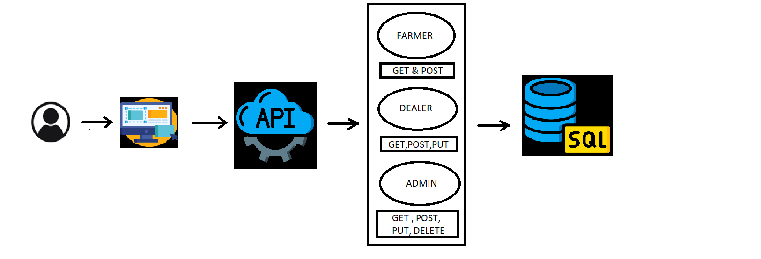

# 6. Architecture Diagram

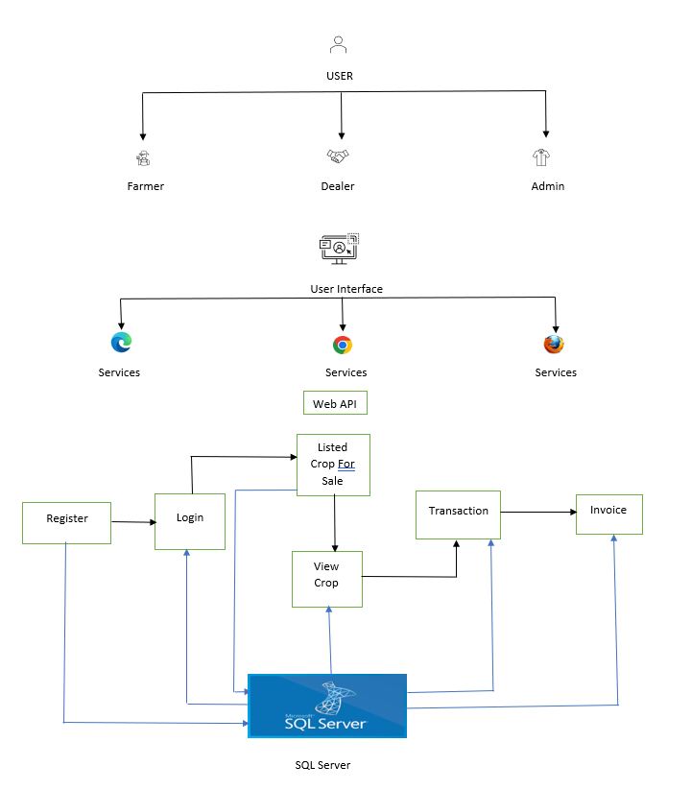

# 7. Flow Diagram

# 8. Use Case Diagram

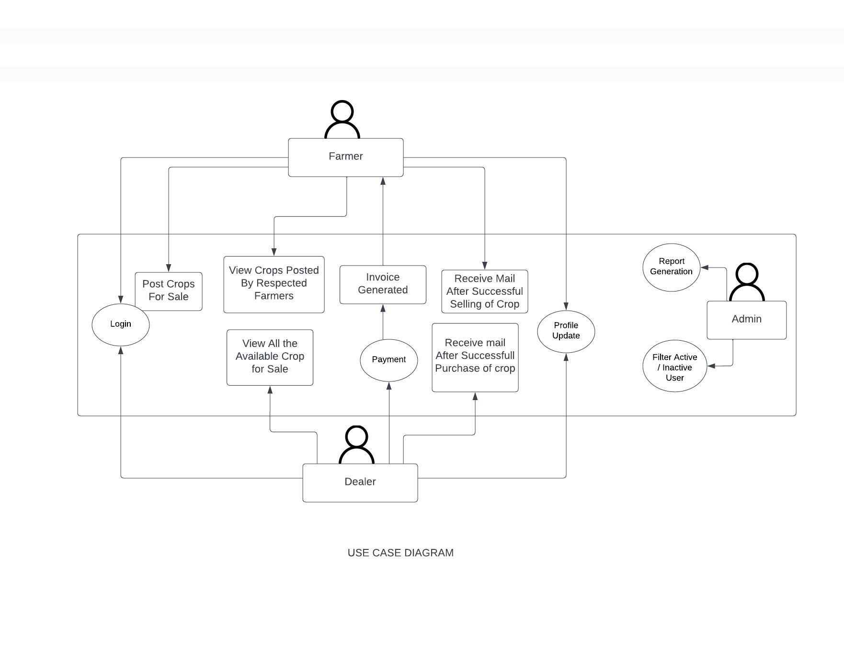

# 9.ClassDiagram

# 10. E-R Diagram

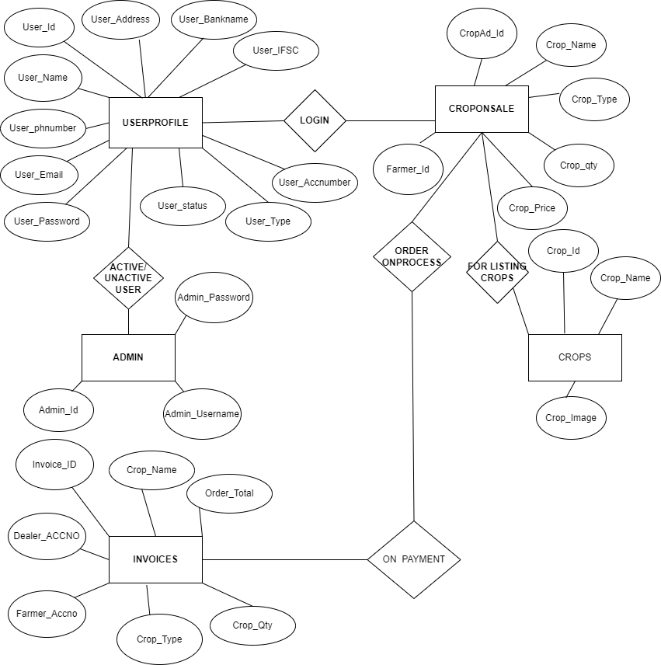

Cropdetail

# 11. Solution Steps—

## 11.1 User Registration:

Users (farmers or dealers) select their role and provide their name, phone number, address, and bank account details during registration.

The system validates the input:

If there are any errors, an error code and description are returned.

If everything is valid, the user details are saved in the database, and a success code is sent.

## 11.2 Crop :

Farmers log in with their username and password.

Farmers post details of the crops they have available for sale, including the crop name, quantity, and price.

The posted crops are listed for potential dealers to see.

## 11.3 Crops Detail:

Dealers log in with their credentials.

Dealers can view the crops listed by the farmers.

When a dealer is interested in purchasing a crop, they proceed with the purchase.

## 11.4 Payment:

The dealer visits the farmer's location to inspect the crop's quality and quantity.

If satisfied, the dealer logs in again and proceeds with the payment.

After successful payment, an invoice is generated and sent to both the farmer and dealer.

## 11.5 Admin Module

Admin will login with his Username and Password.

Admin can able to filter active/inactive farmers and dealers.

The admin can get a Dealer’s report when he clicks to generate a particular dealer report.

# 14. Classes/Function

|  |  |  |
| --- | --- | --- |
| **#** | **Class** | **Description** |
| 1 | User.cs | Model holds the user schema details |
| 2 | UserController.cs | It contains the core business logic for the registration of Farmers. Which calls the registerUser class to create the farmer in database |
| 3 | RegisterUser.cs | This class deals with the data accessibility for Farmer registration |
| 4 | Crop.cs | This class deals with data accessibility for crop list |
| 5 | Crop.cs | It contains the core business logic for the adding the crops of farmers which calls the Crop to add to the database |
| 6 | ActiveUser.cs | This class is for the admin which makes a user active |
| 7 | InactiveUser.cs | This class is for the admin which blocks a user. |
| 8 | UpdateUser.cs | This class is for the admin to update the user details. |
| 9 | DealerReportGenration.cs | This is class is for the admin to generate a particular dealer’s report |
| 10 | Crop.cs | This class contains the data and the logics used when the crops on sale |
| 11 | Invoice.cs | This class is for the invoice generation when the payment  Is completed successfully |

# 15. API Canvas

|  |  |  |  |  |  |
| --- | --- | --- | --- | --- | --- |
| POC | Path | Verb | API Description | Role | Auth |
| Crop-Deal | /farmers | POST | Farmer registration | No | True |
| Crop-Deal | /crops | GET | To get Crop list | Farmer | True |
| Crop-Deal | /sellcrops | POST | To list crops for sale | Farmer | True |
| Crop-Deal | /farmer/id | PUT | To update Farmer details | Farmer | True |
| Crop-Deal | /farmercrops/id | GET | To get list of crops put on sale | Dealer | True |
| Crop-Deal | /farmer/id | DELETE | To remove the Farmer | Admin | True |
| Crop-Deal | /dealer | POST | Dealer registration | NO | True |
| Crop-Deal | /dealer/id | DELETE | To remove the Dealer | Admin | True |
| Crop-Deal | /buycrops | POST | To make payment for the crops | Dealer | True |
| Crop-Deal | /Invoice | GET | To generate invoice | Dealer | True |

# 16. HTTP Status Code

201 – Farmer registered, dealer registered.

200 - Request succeeded

400 – Inputs are invalid

404 – Data not found

502 – Bad gateway